 |   MATHEMATICS METHODS  YEAR 12, UNIT 4  Semester 2, 2021  Test 4  Weighting 7%  [Curriculum references: Logarithms 4.1.1- 4.1.14]
Section One: Calculator–free
Student Name: _____________________________________
Teacher’s Name: _____________________________________

Time allowed for this section
Reading time before commencing work: one minute
Working time for paper: forty minutes
Total Marks: forty-six marks

Materials required/recommended for this section
To be provided by the supervisor
This Question/Answer booklet
Formula sheet
To be provided by the candidate
Standard items: pens (blue/black preferred), pencils (including coloured), sharpener,
correction fluid/tape, eraser, ruler, highlighters
Special items: nil

Important note to candidates
No other items may be taken into the examination room. It is your responsibility to ensure that you do not have any unauthorised material. If you have any unauthorised material with you, hand it to the supervisor before reading any further.

Show all working clearly, in sufficient detail to allow your answers to be checked readily and for marks to be allocated for reasoning. Incorrect answers given without supporting reasoning cannot be allocated any marks. It is recommended that students do not use a pencil, except in diagrams

Question 1. [ 2, 2 = 4 marks]
Express each of the following as a single logarithm.
a) b)

Question 2. [2, 2 = 4 marks]
Evaluate each of the following, showing full working.
a) b)

Question 3. [1, 3 = 4 marks]
If , where x is positive, express each of the following in terms of y.
a) b)

Question 4. [3, 3 = 6 marks]
Give an exact value for $x$ in terms of log₁₀ (simplify your logs)
b)

Question. 5. [1, 1, 1, 2 = 5 marks]
The function is graphed below. Use the graph to answer the questions that follow.
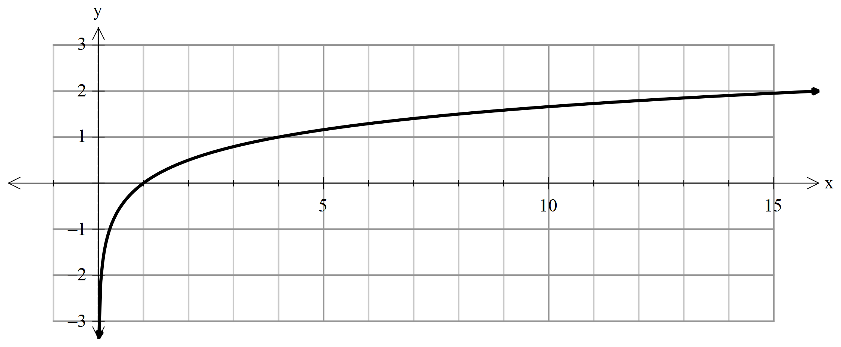

- Find the value of a.

b) Use the graph to approximate to 1 d.p. the solution to

c) Approximate the solution for x if

d) Use the graph to find an approximation to

Question. 6 [3 marks]

Sketch the graph of $y=\log_{2}({x+1)}-2$. Clearly label the key features.

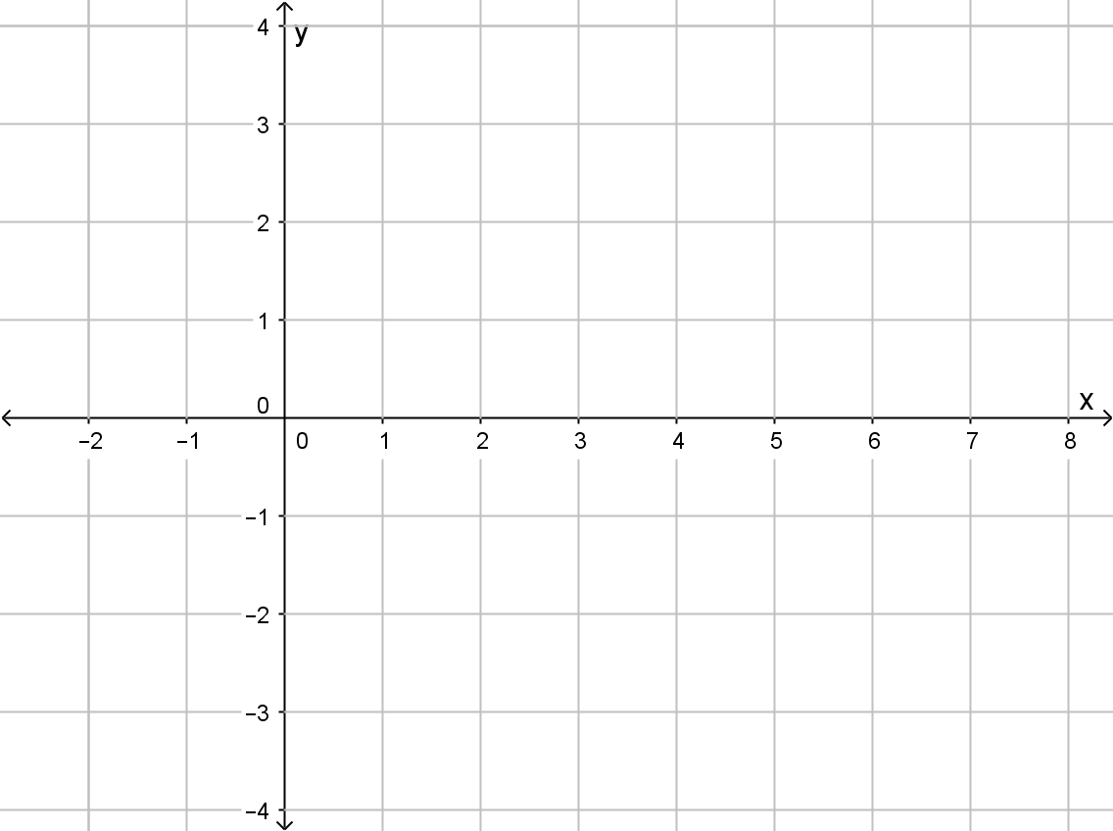

Question. 7. [3, 3, 3 = 9 marks]
Differentiate each of the following with respect to x, showing full working.
(DO NOT SIMPLIFY YOUR ANSWER)
- $If y=x^{2}ln\left(sin x\right) find \frac{dy}{dx}$

Question 8. [ 2, 3 = 5 marks]
Integrate each of the following, showing full working.

Question 9. [2, 4 = 6 marks]
Given $y=\frac{lnx}{x}$
a) Find $\frac{dy}{dx}$

b) Hence, or otherwise, use $\frac{dy}{dx}$to show that

End of Calculator Free Section

Additional working space.

 |   MATHEMATICS METHODS  YEAR 12, UNIT 4: Test 4 2021  Weighting 7%  [Curriculum references: Logarithms 4.1.1- 4.1.14]
Section Two: Calculator–assumed
Student Name: _____________________________________
Teacher’s Name: _____________________________________

Time allowed for this section
Reading time before commencing work: one minute
Working time for paper: fifteen minutes
Total Marks: eighteen marks

Material required/recommended for this section

To be provided by the supervisor
This Question/Answer booklet
Formula Sheet (retained from Section One)

To be provided by the candidate
Standard items: pens (blue/black preferred), pencils (including coloured), sharpener, correction tape/fluid, erasers, ruler, highlighters
Special Items: drawing instruments, templates, notes on one side of an A4 piece of paper and up to three calculators approved for use in the WACE examinations.

Important note to candidates
No other items may be taken into the examination room. It is your responsibility to ensure that you do not have any unauthorised notes or other items of a non–personal nature in the examination room. If you have any unauthorised material with you, hand it to the supervisor before reading any further.
Show all your working clearly. Your working should be in sufficient detail to allow your
answers to be checked readily and for marks to be awarded for reasoning. Incorrect answers given without supporting reasoning cannot be allocated any marks. For any question or part question worth more than two marks, valid working or justification is required to receive full marks. If you repeat an answer to any question, ensure that you cancel the answer you do not wish to have marked.It is recommended that you do not use pencil, except in diagrams.

Question 10. [2, 2, 2, 3 = 9 Marks]
The annual profit, P hundred thousand dollars, of a retail store, is modelled by, $P=2t ln(t)$ for 0 < t < 10, where t is time in years after establishing the store.
- Find the instantaneous rate of change of profit with respect to time when
t = 1.

b) Find when the rate of change of profit, with respect to time, is:
i) $0 per year.

ii) $400 000 per year.

c) Find the largest loss experienced by the store, and when it occurred.

Question 11. [3, 2 = 5 marks]
Synergy, the provider of electricity in Perth, monitors the maximum consumption of electricity over summer measured against the maximum temperatures.

Graphing the data provides us with the following graph, where C is maximum consumption in megawatts and T is the maximum temperature in degrees Celsius.
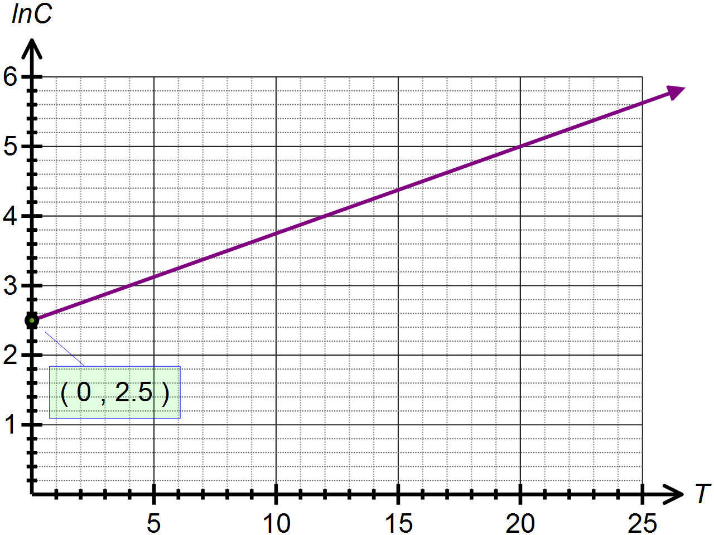

(a) Determine the equation of in terms of .

(b) Use your answer to (a) to determine the exponential function which models the energy consumption based on the maximum temperature recorded.

Question 12. [2, 2 marks]

where A and B are constants.

a) Determine the values of A and B.

b) Hence, find

The End
Additional working space.

